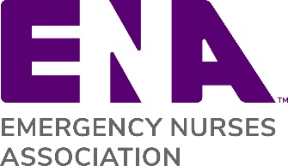

State Welcome Letter Instructions: Rejoining Members

This letter template was created for you to send to your rejoining members. We encourage you to customize the letters for your particular needs.

Step 1: Replace the ENA logo with your state ENA logo
Step 2: The words highlighted in red brackets are for you to customize
Step 3: Make sure to include a link to your state website
Step 4: Also include contact information for someone they can reach out to with questions

Other Membership Letter Templates:
- Welcome Letter for New Members – Welcoming new members to ENA
- Membership Renewal Reminder – Reminder for members who are about to expire
- Lapsed Member Communication – Reaching out to members who have let their membership lapse and giving them an opportunity to rejoin

[REJOINING MEMBER WELCOME LETTER TEMPLATE]
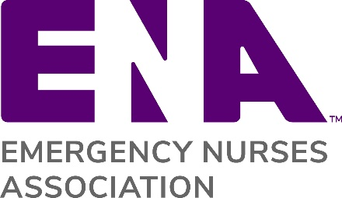
{Replace ENA Logo with State ENA Logo}
{Date}
Dear {Re-joining Member Name},
It is a pleasure to welcome you back to your {State} Council of the Emergency Nurses Association. Our state goals reflect those of the national organization--to bring you quality education, the opportunity to advocate for issues important to emergency nurses, and to give you a framework of support and interaction. A new member recently said, “I went to my first ENA state council meeting and it changed my life forever!” The energy and passion to help one another provide excellent patient care is felt throughout our meetings, courses, and activities. We look forward to having you join us again and hope that you will share your knowledge and expertise.
We continue to grow and offer new opportunities for leadership and professional development on the state level. There are many ways for you to reconnect with local members and obtain the greatest value from your ENA membership. We encourage you to attend local meetings and state conventions and to join a state committee. Topics range from public safety and injury prevention, to trauma education, to pediatric and geriatric education, to membership, to finance and communication, and to government affairs. Additionally, our {State} council also provides scholarships for promoting the future of emergency nursing. {customize this paragraph based on state specific planned activities/benefits}
Please take a few minutes to visit our {State} Council website at {link to website}. And feel free to contact us if you have any questions.
{State Council Contact Information}
Once again, we’re glad you decided to re-join the {State} ENA! Don’t forget as an ENA member, you will receive ENA Connection magazine, the Journal of Emergency Nursing, access to free CE and other exclusive member benefits including ENA University, an all-inclusive hub for emergency nursing education and savings for members on name brand retailers.
We look forward to working with you again!
Sincerely,
ENA {State} President

