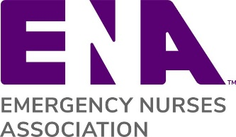

Membership Renewal Reminder Instructions

This letter template was created for you to send to your members you have an upcoming renewal. We encourage you to customize the letters for your particular needs. Note: This template can be used for an email or letter correspondence

Step 1: Replace the ENA logo with your state ENA logo
Step 2: The words highlighted in red brackets are for you to customize
Step 3: Make sure to include a link to your state website
Step 4: Also include contact information for someone they can reach out to with questions

Other Membership Letter Templates:
- Lapsed Member Communication – Reaching out to members who have let their membership lapse and giving them an opportunity to rejoin
- Welcome Letter for New Members – Welcoming new members to ENA
- Welcome Letter for Rejoining Members – Welcoming rejoining members back to ENA

[MEMBERSHIP RENEWAL REMINDER TEMPLATE]
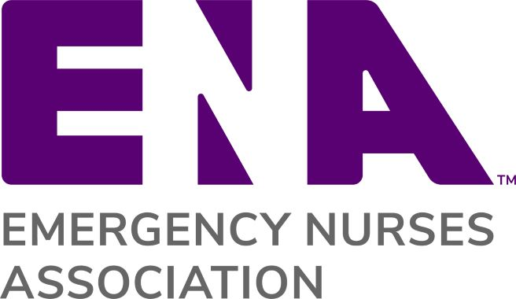
{Replace ENA Logo with State ENA Logo}

Dear {Member Name},

Your Emergency Nurses Association membership is expiring soon. Please don’t delay in renewing your membership. You are important to our state council and we want to make sure you are able to continue to take advantage of valuable ENA member benefits.

You are one of {total number of state council members} members of the {State} ENA State Council who work together to provide continuing education, opportunities to advocate for important issues, and a framework of support and engagement for emergency nurses in {State}.

Please renew your ENA membership at www.ena.org/renew or by responding to your mailed renewal invoice. By renewing you will continue to receive ENA Connection magazine, the Journal of Emergency Nursing, access to free CE and other exclusive member benefits including ENA University, an all-inclusive hub for emergency nursing education and savings for members on name brand retailers.

As you renew your commitment to ENA, I look forward to a conversation on how you can engage even further with the {State} ENA State Council in the coming year. There are many opportunities for leadership and professional development at the state and national level. I encourage you visit our website {link to website} to find the latest information on events and programs in {State}.

Thank you for your continued commitment to ENA!

Sincerely,

{Name}
{State} ENA President
{Email}
{Phone}
{State Council website}

