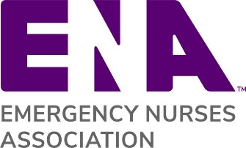

Lapsed Member Communication Instructions

This letter template was created for you to send to your members who have let their membership lapse and you are reaching out to them to rejoin ENA. We encourage you to customize the letters for your particular needs. Note: This template can be used for an email or letter correspondence

Step 1: Replace the ENA logo with your state ENA logo
Step 2: The words highlighted in red brackets are for you to customize
Step 3: Make sure to include a link to your state website
Step 4: Also include contact information for someone they can reach out to with questions

Other Available Membership Letter Templates:
- Membership Renewal Reminder – Reminder for members who are about to expire
- Welcome Letter for New Members – Welcoming new members to ENA
- Welcome Letter for Rejoining Members – Welcoming rejoining members back to ENA
[ENA LAPSED MEMBER COMMUNICATION TEMPLATE]
Subject: {State} ENA needs you
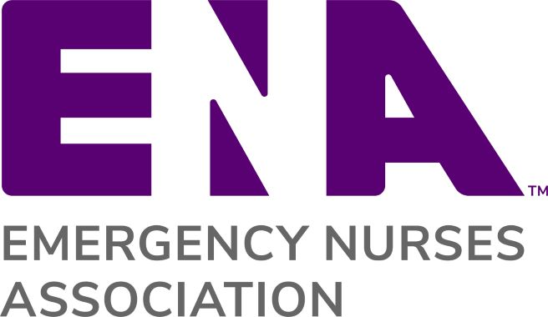
{Replace ENA Logo with State ENA Logo}
{Date}
Dear {Lapsed Member Name},
The {State} ENA State Council invites you to rejoin the Emergency Nurses Association. We miss your voice in our organization and want to make sure we continue to represent the concerns and issues facing emergency nurses in {State}. If you are considering rejoining the Emergency Nurses Association, now is the time!

Rejoin ENA at http://www.ena.org/renew to take advantage of exclusive member benefits, including free CE and generous conference discounts.

There are many benefits to rejoining ENA. We’ve been busy {customize with state’s top three initiatives}. However, in order to continue to meet our goals and create a strong state council, we need your help. There are many opportunities for you to become an active member as we are always looking for volunteers to support our education, networking, and advocacy efforts.

In addition to our state activities, ENA, the trusted leader in emergency nursing, offers many benefits and opportunities at the national level. The Emergency Nursing conference features 100 + sessions, labs, simulations, and drills. You will have access to savings on name brand retailers, ENA University, an all inclusive hub for emergency nursing education as well as the latest emergency nursing news at your fingertips with a free print and app subscription to ENA Connection magazine and the Journal of Emergency Nursing and so much more.

Please feel free to contact me or ENA Member Services at membership@ena.org or 800.900.9659. Let us help you make the most of your membership this year.

Sincerely,

[Name}
{State} ENA President
{Email address}
{Phone}
{State Council website}

