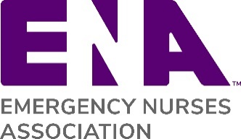

Thank You Instructions and Template: General Member Thank You

This letter template was created for you to send a thank you note to a general member. We encourage you to customize the letters for your particular needs. Note: This template can be used for an email or letter correspondence

Step 1: Replace the ENA logo with your state ENA logo
Step 2: The words highlighted in red brackets are for you to customize
Step 3: Also include your contact information

If you are looking to send a thank you letter to a volunteer, please refer to the Volunteer Thank You template on the ENA Brand Center.

[GENERAL MEMBER THANK YOU TEMPLATE]
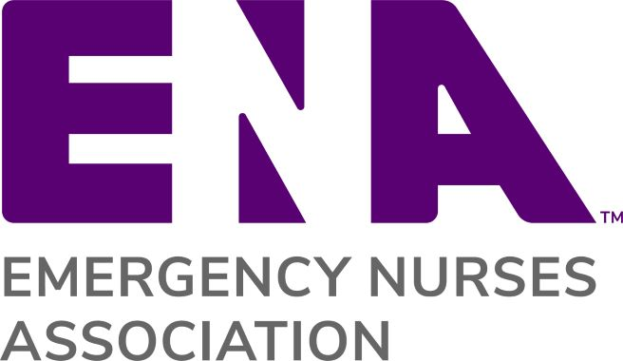
{Replace ENA Logo with State ENA Logo}

{Date}
Dear {Member Name},
I wanted to take an opportunity to thank you very much for your contributions and dedication to the {State} ENA State Council and to the emergency nursing profession.

As a member of ENA, you are part of a community of more than 50,000 emergency nursing professionals who work together to increase education, networking, and advocacy opportunities. Your contributions to the {State} ENA State Council help engage other members in our state.

Without your support we would not be able to accomplish all that we do. Your willingness to take time out of your busy schedule to be an active participant in the {State} ENA State Council makes a difference not only in our state, but also for your colleagues across the nation fighting for key issues such as workplace violence prevention.

Thank you again for your continued support of the {State} ENA State Council. Please let me know if there is anything we can do to support you, and I look forward to a continued partnership.

Sincerely,

{Name}
{State} ENA President
{Email}
{Phone}
{State Council Website]

