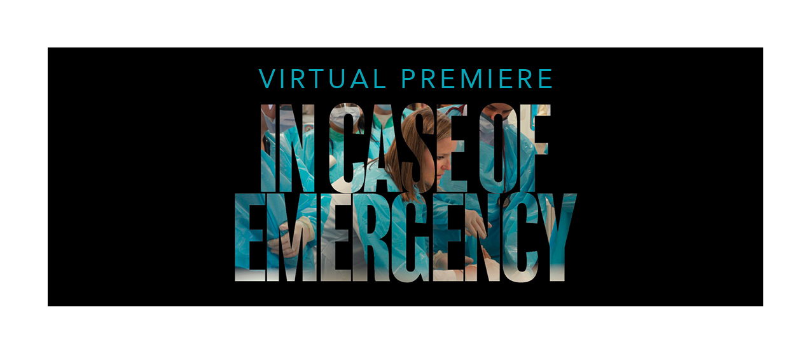
Dear: (fillable)
I enthusiastically request your support to virtually attend the “In Case of Emergency” film premiere taking place at 8 p.m. Eastern time on Oct. 14 – during Emergency Nurses Week. This year marks ENA’s 50th anniversary and to celebrate and recognize all emergency nurses for their hard work, perseverance and indelible impact on society, ENA partnered with filmmaker Carolyn Jones on the documentary film “In Case of Emergency,” which takes an up-close, personal look at peers in our specialty who take on all challenges on the front lines of health care.
For this reason, I’m interested in virtually attending the screening. The film will provide me with additional knowledge, perspective and insights to make a positive impact at our hospital and to help us achieve our goals.
Here is an estimated breakdown of the costs and the dates in which I am requesting time off:
Event: “In Case of Emergency” Film Premiere and Q&A session
Date and time: Oct. 14 – 8 p.m. Eastern
Registration: Free!
Please accept this letter as my proposal to virtually watch the screening of “In Case of Emergency.”
[Your standard close]

